**Project Report**

**Online Doctor Appointment**

**Table of Contents**

1. Introduction
2. Objectives
3. Tools / Environment Used
4. Analysis Document (This should include SRS in proper structure based on Software Engineering concepts, E-R diagrams/Class diagrams/any related diagrams (if the former are not applicable), Data flow diagrams/other similar diagrams (if the former is not applicable), Data dictionary)
5. Design Document (Modularization details, Data integrity & constraints including database design, Procedural design, User interface design)
6. Program code (Complete code (well indented)/Detailed specification instead of code*, Comments & Description. The program code should always be developed in such a way that it includes complete error handling, passing of parameters as required, placement of procedure/function statements as needed.)
7. Testing (Test case designs are to be included separately for Unit testing, Integration testing, System testing; Reports of the outcome of Unit testing, Integration testing, System testing are to be included separately. Also, details of debugging and code improvement are to be included.)
8. Input and Output Screens
9. Implementation of Security for the Software developed (In case, you have set up a User Name and Password for your software, you should ensure the security of User Name and Password during transmission to server.)
10. Limitations of the Project
11. Future Application of the Project
12. References and Bibliography
13. **Introduction**
    1. **Purpose**

This document is to describe all the software requirement specification (SRS) for the Online Doctor Appointment (ODA). The system aims to help the patients to take appointment online through internet and track their records through it. With the increase in the number of patients visiting, it has become difficult to manage the appointment system manually. The purpose of this project is to solve these complications by creating custom-built database software to manage the appointment system.

* 1. **Document Conventions**

When writing this document it was inherited that all requirements have the different priority levels. The levels of authentication are provided in four different aspects i.e. The Admin, The Doctors, The Users and The Patients.

* 1. **Features**
* Authentication for different users.
* Real-time validation of all fields and database to prevent errors.
* Printing of appointment letter.
  1. **System Overview**

There four Main Modules in Automated Doctor Consulting System they are

1. **Patient Module**

The Patient registration the user can Login to this site with his/her Unique Id and Password. To get an appointment from a doctor we need the user to pay some minimum amount through credit card. The Doctor list is categorized by his/her specialization and Location like CARDIOLOGIST, SKIN, CHILD SPECIALIST etc. and Rajajinagar, Jayanagar, Malleshwaram respectively. So that the user can easily access the doctor for his/her treatment. The user can fix Appointment with a particular doctor by specifying the time, which is convenient for them. Based on the Doctors availability in the current working hospital can fix appointments with convenient time and date. Patient can also cancel the appointments within the time duration given by the admin.

1. **Doctor Module**

Administrator does Doctor registration. Every Doctor will have their own unique Id and Password with which, they will login to this site. After they logged into this site. From there by choosing the link, they can see their appointments. He/she can see their new appointments. After attending the patient, the Doctor selects a particular patient Id for checking the details.Doctor can delete his/her appointments after attending the patients. Doctors gets advance amount paid by the patients. Doctors can also message to the admin regarding their availability in the city so that the admin can update in the site. Doctors can also change their password if they want to change.

1. **Administrator Module**

A Genuine person from the Administrator side will collect information about the Doctor like his/her Qualification, specialization, Address, etc for Registration. After filtering the invalid data, the Doctor Details will be uploaded in Automated Doctor Consulting site. The Administrator can view the Account information and can also view the suggestion (feedbacks) given by different users of this site. The Administrator is the one, who updates latest Health Tips provided in this site. He can view all the details regarding users/patients and doctors. He can update the doctor’s information if he/she gets any messages from the doctors.

1. **General User Module**

General Users are those who have not registered in this site.

* They can view general information about the Doctors.
* They view the Health Tips.
* They can give their suggestion about this site.
* They can register themselves and become a member of Doctor Consulting System.

1. **Objectives**
2. **Tools / Environment Used**

**Hardware**

**Processor :** Pentium 2.4 GHz or above.

**Memory :** 256 MB RAM or above.

**Cache Memory :** 128 KB or above.

**Hard Disk :** 3 GB or above [at least 3 MB free space required].

**Software**

**Operating System :**  Windows XP, Windows 7.

**Font-End Tool :**  HTML, Java Script, CSS.

**Back-End :**  My SQL.

**Front End**

We have implemented **JavaScript** for all the Client side validations. Client side JavaScript is designed to reside inside **HTML** document & ensure they run properly. It is object based, event driven, platform independent. These are important parts of any Web application to implement Client side Validations and the invalid data is not submitted. The form is not submitted until user fills in correct data. It is extremely useful to restrict mistakes by user.

**PHP :**

PHP is a server-side scripting language designed for web development but also used as a general-purpose programming language. While PHP originally stood for Personal Home Page. It now stands for PHP: Hypertext Pre-processor, a recursive backronym.

PHP code is interpreted by a web server with a PHP processor module, which generates the resulting web page: PHP commands can be embedded directly into an HTML source document rather than calling an external file to process data. It has also evolved to include a command-line interface capability and can be used in standalone graphical applications.

PHP is free software released under the PHP License. PHP can be deployed on most web servers and also as a standalone shell on almost every operating system and platform, free of charge.

PHP is a general-purpose scripting language that is especially suited to server-side web development where PHP generally runs on a web server. Any PHP code in a requested file is executed by the PHP runtime, usually to create dynamic web page content or dynamic images used on websites or elsewhere. It can also be used for command-line scripting and client-side graphical user interface (GUI) applications. PHP can be deployed on most web servers, many operating systems and platforms, and can be used with many relational database management systems (RDBMS). Most web hosting providers support PHP for use by their clients. It is available free of charge, and the PHP Group provides the complete source code for users to build, customize and extend for their own use.

To start, you must have a computer that runs an appropriate operating system like Microsoft Windows >= XP Home Edition: that includes Windows XP Home Edition, Windows XP Professional, Windows 2000 Professional, or any version of Windows Server 2003 or Windows 7. In this case, you must install phpMyAdmin.

Originally designed to create dynamic web pages, PHP now focuses mainly on server-side scripting, and it is similar to other server-side scripting languages that provide dynamic content from a web server to a client, such as Microsoft's ASP.NET, Sun Microsystems' JavaServer Pages, and mod_perl. PHP has also attracted the development of many software frameworks that provide building blocks and a design structure to promote rapid application development (RAD). Some of these include PRADO, CakePHP, Symfony, CodeIgniter, Laravel, Yii Framework, and Zend Framework, offering features similar to other web application frameworks.

**HTML :**

HTML or HyperText Markup Language is the main markup language for creating web pages and other information that can be displayed in a web browser.

HTML is written in the form of HTML elements consisting of tags enclosed in angle brackets (like <html>), within the web page content. HTML tags most commonly come in pairs like <h1> and </h1>, although some tags represent empty elements and so are unpaired, for example <img>. The first tag in a pair is the start tag, and the second tag is the end tag (they are also called opening tags and closing tags). In between these tags web designers can add text, further tags, comments and other types of text-based content.

The purpose of a web browser is to read HTML documents and compose them into visible or audible web pages. The browser does not display the HTML tags, but uses the tags to interpret the content of the page.

HTML elements form the building blocks of all websites. HTML allows images and objects to be embedded and can be used to create interactive forms. It provides a means to create structured documents by denoting structural semantics for text such as headings, paragraphs, lists, links, quotes and other items. It can embed scripts written in languages such as JavaScript which affect the behaviour of HTML web pages.

Web browsers can also refer to Cascading Style Sheets (CSS) to define the look and layout of text and other material. The W3C, maintainer of both the HTML and the CSS standards, encourages the use of CSS over explicit presentational HTML.

**CSS :**

CSS specifies a priority scheme to determine which style rules apply if more than one rule matches against a particular element. In this so-called cascade, priorities or weights are calculated and assigned to rules, so that the results are predictable.

CSS can also allow the same markup page to be presented in different styles for different rendering methods, such as on-screen, in print, by voice (when read out by a speech-based browser or screen reader) and on Braille-based, tactile devices. It can also be used to allow the web page to display differently depending on the screen size or device on which it is being viewed. While the author of a document typically links that document to a CSS file, readers can use a different style sheet, perhaps one on their own computer, to override the one the author has specified. However if the author or the reader did not link the document to a specific style sheet the default style of the browser will be applied.

CSS is designed primarily to enable the separation of document content from document presentation, including elements such as the layout, colors, and fonts.[1] This separation can improve content accessibility, provide more flexibility and control in the specification of presentation characteristics, enable multiple pages to share formatting, and reduce complexity and repetition in the structural content (such as by allowing for tableless web design).

Cascading Style Sheets (CSS) is a style sheet language used for describing the look and formatting of a document written in a markup language. While most often used to style web pages and interfaces written in HTML and XHTML, the language can be applied to any kind of XML document, including plain XML, SVG and XUL. CSS is a cornerstone specification of the web and almost all web pages use CSS style sheets to describe their presentation.

**Absolute positioning**

An absolutely positioned item has no place in, and no effect on, the normal flow of other items. It occupies its assigned position in its container independently of other items.

Position: top, bottom, left, and right

There are four possible values of the position property. If an item is positioned in any way other than static, then the further properties top, bottom, left, and right are used to specify offsets and positions.

**Advantages**

* Separation of content from presentation
* Page reformatting
* Accessibility
* Bandwidth
* Site-wide consistency
* Positioning

**JavaScript :**

JavaScript (JS) is a dynamic computer programming language. It is most commonly used as part of web browsers, whose implementations allow client-side scripts to interact with the user, control the browser, communicate asynchronously, and alter the document content that is displayed. It is also being used in server-side programming, game development and the creation of desktop and mobile applications.

JavaScript is a prototype-based scripting language with dynamic typing and has first-class functions. Its syntax was influenced by C. JavaScript copies many names and naming conventions from Java, but the two languages are otherwise unrelated and have very different semantics. The key design principles within JavaScript are taken from the Self and Scheme programming languages. It is a multi-paradigm language, supporting object-oriented, imperative, and functional programming styles.

The most common use of JavaScript is to write functions that are embedded in or included from HTML pages and that interact with the Document Object Model (DOM) of the page.

JavaScript was formalized in the ECMAScript language standard and is primarily used as part of a web browser (client-side JavaScript). This enables programmatic access to computational objects within a host environment.

The application of JavaScript to use outside of web pages—for example, in PDF documents, site-specific browsers, and desktop widgets—is also significant. Newer and faster JavaScript VMs and platforms built upon them (notably Node.js) have also increased the popularity of JavaScript for server-side web applications. On the client side, JavaScript was traditionally implemented as an interpreted language but just-in-time compilation is now performed by recent (post-2012) browsers.

**Back End**

We have used My SQL. My SQL provides efficient/effective solution for major database tech.

* Large database and space management.
* Many concurrent database users.
* High transaction processing requirement.
* High availability.
* Industry accepted standards.
* Manageable security.
* Portability.

**MY SQL :**

My SQL is an application used to create computer databases for the Microsoft Windows family of server operating systems. It provides an environment used to generate databases that can be accessed from workstations, the web, or other media such as a personal digital assistant (PDA). MY SQL is probably the most accessible and the most documented enterprise database environment right now. This also means that you can learn it a little quicker than most other database environments on the market.

To start, you must have a computer that runs an appropriate operating system like Microsoft Windows >= XP Home Edition: that includes Windows XP Home Edition, Windows XP Professional, Windows 2000 Professional, or any version of Windows Server 2003 or Windows 7. In this case, you must install phpMyAdmin.

**What is SQL Used for?**

Using SQL one can create and maintain data manipulation objects such as table, views, sequence etc. These data manipulation objects will be created and stored on the server's hard disk drive, in a table space, to which the user has been assigned.

Once these data manipulation objects are created, they are used extensively in commercial applications.

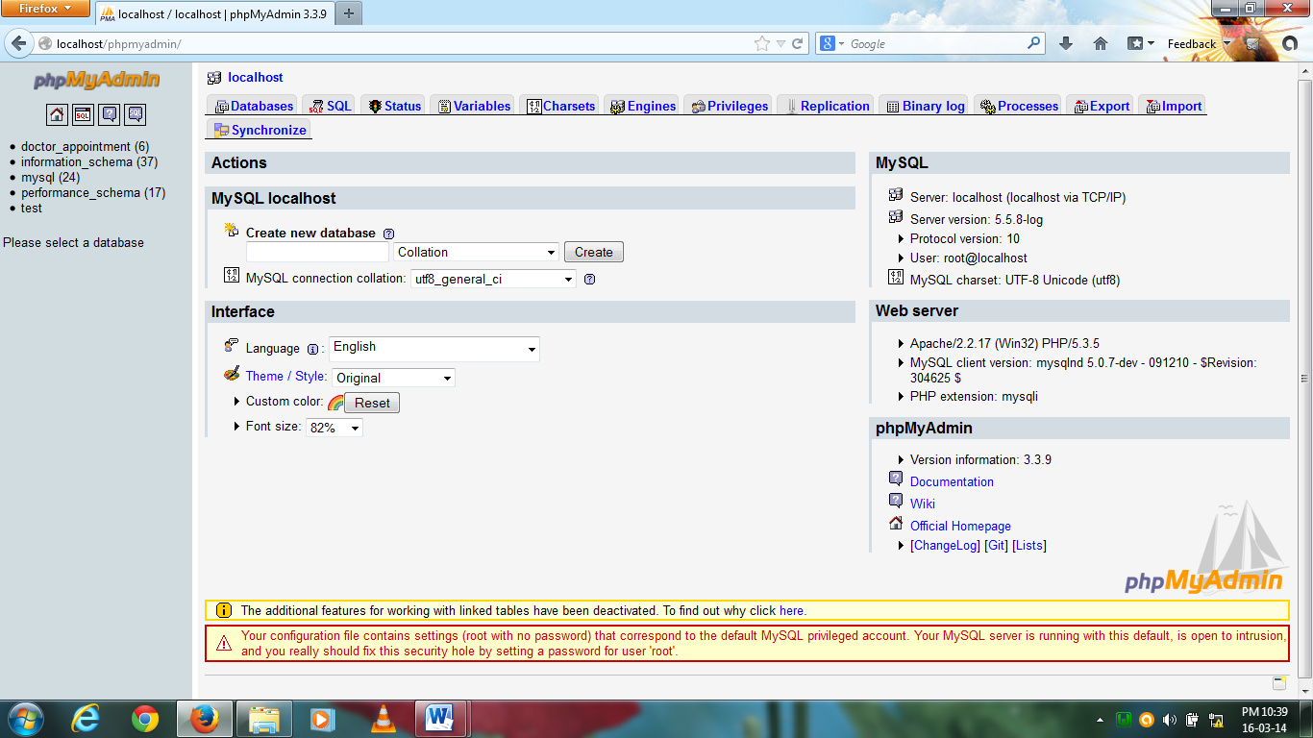

**DML, DCL, DDL**

In addition to the creation of data manipulation objects, the actual manipulation of data within these objects is done using SQL.

The SQL sentences that are used to create these objects are called DDL's or Data Definition Language. The SQL sentences used to manipulate data within these objects are called DML's or Data Manipulation Language. The SQL sentences, which are used to control the behaviour of these objects, are called DCL's or Data Control Language.

**Software Requirement Specification (SRS)**

What are the benefits of a **SRS**?

The IEEE 830 standard defines the benefits of a good SRS:

* ***Establish the basis for agreement between the customers and the suppliers on what the software product is to do.*** The complete description of the functions to be performed by the software specified in the SRS will assist the potential users to determine if the software specified meets their needs or how the software must be modified to meet their needs. [NOTE: We use it as the basis of our contract with our clients all the time].
* ***Reduce the development effort.*** The preparation of the SRS forces the various concerned groups in the customer’s organization to consider rigorously all of the requirements before design begins and reduces later redesign, recoding, and retesting. Careful review of the requirements in the SRS can reveal omissions, misunderstandings, and inconsistencies early in the development cycle when these problems are easier to correct.
* ***Provide a basis for estimating costs and schedules.*** The description of the product to be developed as given in the SRS is a realistic basis for estimating project costs and can be used to obtain approval for bids or price estimates. [NOTE: Again, we use the SRS as the basis for our fixed price estimates].
* ***Provide a baseline for validation and verification.*** Organizations can develop their validation and Verification plans much more productively from a good SRS. As a part of the development contract, the SRS provides a baseline against which compliance can be measured. [NOTE: We use the SRS to create the Test Plan].
* ***Facilitate transfer.*** The SRS makes it easier to transfer the software product to new users or new machines. Customers thus find it easier to transfer the software to other parts of their organization, and suppliers find it easier to transfer it to new customers.
* ***Serve as a basis for enhancement.*** Because the SRS discusses the product but not the project that developed it, the SRS serves as a basis for later enhancement of the finished product. The SRS may need to be altered, but it does provide a foundation for continued production evaluation.